PROBLEM STATEMENT :
A smart manufacturing company plans to develop an energy-efficient processor for an industrial monitoring system. The processor should efficiently handle sensor data and real-time processing requirements. Analyze the functional units, including CPU, memory, buses, and I/O components. Apply the instruction execution cycle and addressing modes for efficient instruction processing. Evaluate processor performance using CPI, clock cycles, execution time, and benchmarking. Design a suitable pipelined datapath to improve instruction throughput. Analyze data, control, and
structural hazards occurring during pipeline execution. Apply suitable techniques such as forwarding, stalling, and branch prediction to reduce hazards. Compare superscalar processing, out-of-order execution, and speculative execution. Analyze the suitability of simultaneous multithreading (SMT) for improving processor utilization. Design a hierarchical memory system using L1, L2, and L3 caches with virtual memory.
Compare SRAM, DRAM, NAND Flash, MRAM, and RRAM based on latency, bandwidth, throughput, and power. Recommend an optimized processor and memory organization for improved performance and energy efficiency.
Justify the proposed design based on performance, power consumption, and resource utilization. Explain how the design supports SDG 7, SDG 9, and SDG 12 through clean energy use, innovation, and responsible resource consumption.

1. INTRODUCTION
Modern smart manufacturing systems continuously collect data from sensors such as temperature, pressure, vibration, humidity and machine-speed sensors. The processor used in such a system must process sensor information in real time while consuming minimum power.
The proposed system is therefore designed as an energy-efficient industrial monitoring processor. It combines:
- CPU and ALU
- Register file
- Control unit
- Pipelined datapath
- L1, L2 and L3 cache
- Virtual memory
- Memory controller
- System bus
- Sensor and I/O interfaces
- Low-power execution techniques
The architecture is designed to provide a balance between performance, latency, power consumption, cost and reliability.

ASSESSMENT 1

FUNCTIONAL UNITS, INSTRUCTION EXECUTION, ADDRESSING MODES & PERFORMANCE ANALYSIS

CO1:

1.1 Proposed Processor Architecture
The proposed processor contains the following major functional units.
Functional Unit | Function | Application in Industrial Monitoring
Control Unit | Controls instruction execution | Controls sensor-data processing
ALU | Performs arithmetic and logical operations | Temperature, pressure, and vibration calculations
Register File | Stores temporary operands/results | Fast storage for sensor values
Program Counter (PC) | Stores address of next instruction | Controls instruction sequence
Instruction Register | Stores current instruction | Holds instruction during decoding
Cache Memory | Stores frequently used data/instructions | Reduces memory access latency
Main Memory | Stores programs and data | Stores monitoring software and sensor data
Memory Controller | Controls memory transactions | Coordinates CPU and DRAM
Bus | Transfers data, addresses, and control signals | Connects CPU, memory, and I/O
I/O Controller | Handles external devices | Interfaces with sensors and actuators
Interrupt Controller | Handles urgent events | Responds quickly to abnormal sensor values

1.2 System Architecture

Proposed architecture
.
Industrial Sensors
Temp / Pressure etc.

I/O Unit

ALU
Arithmetic & Logic Ops
CPU
Control Unit

CPU
Registers & Instructions

L3 Cache
L2 Cache
L1 Cache

Main Memory DRAM

Secondary Storage

1.3 CPU Functional Units

Control Unit
The control unit interprets instructions and generates control signals.
Applied example:
When a temperature sensor sends a value, the CPU may execute:
LOAD → ADD → COMPARE → BRANCH → STORE
The control unit ensures that each instruction is executed in the correct sequence.

ALU
The ALU performs:
- Addition
- Subtraction
- Comparison
- AND
- OR
- XOR
- Shift operations
For example:
Temperature = 85°C
Threshold = 80°C

ALU:
85 > 80
The comparison result can trigger an alarm.

Registers
Registers provide extremely fast temporary storage.
Example:
R1 = Temperature
R2 = Threshold
R3 = Result
Instruction:
CMP R1, R2
The result is then used to determine whether the machine is operating safely.

1.5 Addressing Modes
Different addressing modes can be applied according to the sensor-processing requirement.
Addressing Mode | Example | Application
Immediate | ADD R1, #10 | Add fixed threshold
Register | ADD R1, R2 | Sensor calculations
Direct | LOAD R1, 1000 | Access fixed memory location
Indirect | LOAD R1, (R2) | Access sensor buffer
Indexed | LOAD R1, 100(R2) | Array processing
Base + Offset | LOAD R1, 8(R2) | Structure access

Analysis
Immediate addressing is efficient when constants are used.
Register addressing is faster because it avoids memory access.
Indexed addressing is useful for sensor arrays.
For example:
Sensor[0]
Sensor[1]
Sensor[2]
Sensor[3]
An indexed address can efficiently access each sample.

1.6 Performance Analysis
The main performance parameters are:
- CPI
- Clock cycles
- Clock frequency
- Execution time
- Throughput
- Benchmark performance

Formula
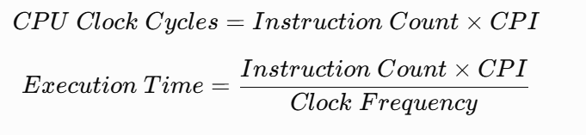

Example Calculation
Assume:
- Instruction count = 1,000,000
- CPI = 1.5
- Clock frequency = 1 GHz

Clock cycles
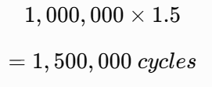

Execution time
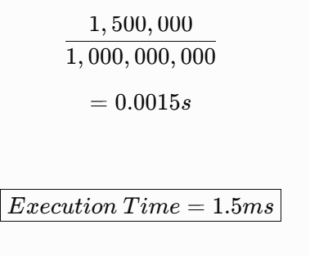

L4 Analysis
Reducing CPI directly reduces execution time if instruction count and clock frequency remain constant.
For example, if CPI is reduced from 1.5 to 1.2:
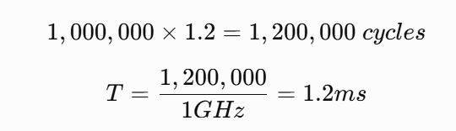
Therefore, the execution time improves from 1.5 ms to 1.2 ms.
RESULT
Parameter | Value
Instruction Count | 1,000,000
Original CPI | 1.5
Improved CPI | 1.2
Clock Frequency | 1 GHz
Original Execution Time | 1.5 ms
Improved Execution Time | 1.2 ms
Improvement | 20%

ASSESSMENT 2

PIPELINED PROCESSOR ORGANIZATION & HAZARD ANALYSIS

CO3:

2.1 Proposed 5-Stage Pipeline
A 5-stage pipeline is selected because it provides good instruction throughput without excessive hardware complexity.
IF → ID → EX → MEM → WB
Where:
- IF = Instruction Fetch
- ID = Instruction Decode
- EX = Execute
- MEM = Memory Access
- WB = Write Back
2.2 Pipeline Datapath
IF

Instruction Fetch
WB

Write Back
MEM

Memory Access
EX

Operation
ID

Instruction Decode

2.3 Application of Pipeline
Consider four instructions:
I1: LOAD R1, [Sensor]
I2: ADD R2, R1, R3
I3: CMP R2, R4
I4: STORE R2, [Memory]
Pipeline operation:
Cycle | I1 | I2 | I3 | I4
1 | IF
2 | ID | IF
3 | EX | ID | IF
4 | MEM | EX | ID | IF
5 | WB | MEM | EX | ID
6 |  | WB | MEM | EX
7 |  |  | WB | MEM

2.4 Data Hazard – L4
A data hazard occurs when one instruction depends on the result of another instruction.
Example:
I1: ADD R1,R2,R3
I2: SUB R4,R1,R5
I2 requires the value produced by I1.

Solution: Forwarding
Instead of waiting until I1 completes write-back, the result can be forwarded directly from the ALU pipeline stage to the next instruction.

Analysis
Forwarding reduces pipeline stalls and improves throughput.

2.5 Load-Use Hazard
Example:
I1: LOAD R1,[1000]
I2: ADD R2,R1,R3
The data from the load instruction may not be available early enough.

Solution
A one-cycle stall can be inserted.
IF → ID → STALL → EX → MEM → WB
This prevents incorrect data from being used.

2.6 Control Hazard
A control hazard occurs due to branch instructions.
Example:
BEQ R1,R2,Target
The processor may fetch the wrong next instruction before knowing whether the branch is taken.

Solution: Branch Prediction
The processor predicts whether the branch will be taken.
Two approaches are:
- Static branch prediction
- Dynamic branch prediction
Dynamic prediction uses previous branch behavior to improve accuracy.

Applied example
If a monitoring loop executes repeatedly:
while(sensor < threshold)
the branch is often predictable.
Therefore, branch prediction can reduce pipeline flushing.

2.7 Structural Hazard
A structural hazard occurs when two pipeline stages require the same hardware resource simultaneously.
Example:
Instruction Fetch → Memory
Data Access → Same Memory
Both may require the same memory port.

Solution
Use separate:
- Instruction cache
- Data cache
This is one reason for using an L1 instruction cache and L1 data cache.
2.8 Hazard Comparison
Hazard | Cause | Example | Solution
Data | Instruction dependency | ADD followed by SUB | Forwarding
Load-use | Load result unavailable | LOAD followed by ADD | Stall + forwarding
Control | Branch decision | BEQ | Branch prediction
Structural | Resource conflict | Shared memory | Separate resources

2.9 Superscalar Processing
A superscalar processor can issue multiple instructions in one clock cycle.
Example:
Cycle 1:
ADD + LOAD

Advantage
Higher instruction throughput.

Limitation
Requires more hardware and increases power consumption.

2.10 Out-of-Order Execution
In out-of-order execution, instructions are executed when their operands and resources are available rather than strictly following program order.
Example:
I1: LOAD R1
I2: ADD R2,R1,R3
I3: ADD R5,R6,R7
If I2 is waiting for memory, I3 can execute first

Analysis – L4
This improves hardware utilization but requires:
- Reservation stations
- Register renaming
- Reorder buffer
- More control logic
Therefore, it increases complexity and power consumption.

2.11 Speculative Execution
Speculative execution allows the processor to execute instructions before it is certain that they are required.
Example:
if (temperature > threshold)
execute alarm routine
The processor predicts the branch and begins execution.

Advantage
Improves performance.

Disadvantage
Wrong predictions cause wasted work and increased energy consumption.

2.12 SMT – Simultaneous Multithreading
SMT allows multiple threads to use processor resources simultaneously.

Suitability for industrial monitoring
SMT can improve utilization when several independent workloads exist:
Thread 1 → Sensor processing
Thread 2 → Communication
Thread 3 → Diagnostic monitoring
However, for a strongly real-time system, excessive sharing can make timing less predictable.

Recommendation
Limited SMT or no SMT is recommended for the basic industrial processor unless multiple parallel workloads justify the extra complexity.
2.13 Recommendation
Technique | Performance | Power | Complexity | Suitability
Basic Pipeline | Medium | Low | Low | Excellent
Superscalar | High | Medium/High | High | Good
Out-of-Order | Very High | High | Very High | Moderate
Speculative Execution | High | Medium/High | High | Good
SMT | High for parallel workloads | Higher | High | Conditional

ASSESSMENT 3

HIERARCHICAL MEMORY SYSTEM & PERFORMANCE EVALUATION

CO4:
3.1 Proposed Memory Hierarchy
CPU

L1 Cache
SRAM - Fast

L2 Cache
SRAM

L3 Cache
Shared

Main Memory
DRAM

NAND Flash
Storage

3.2 L1 Cache
L1 is the smallest and fastest cache.
Proposed:
- L1 Instruction Cache = 32 KB
- L1 Data Cache = 32 KB

Application
Frequently accessed sensor-processing instructions and data are kept in L1.

Benefit
Very low latency.

3.3 L2 Cache
Proposed L2:
512 KB
L2 stores data not found in L1.
It is slower than L1 but larger.

3.4 L3 Cache
Proposed L3:
8 MB
L3 acts as the final cache before main memory.
It reduces expensive DRAM accesses.

3.5 Virtual Memory
Virtual memory allows programs to use virtual addresses.
The virtual address is divided into:

3.6 Cache Hit and Miss

Cache Hit
Requested data is found in cache.

Cache Miss
Requested data is not found and must be obtained from the next memory level.
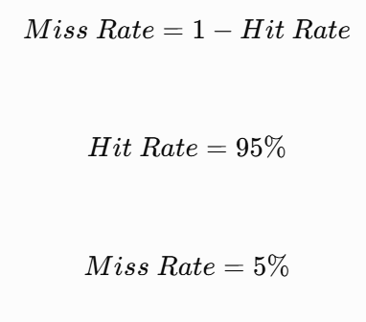

3.7 AMAT Calculation
Average Memory Access Time:

Assume:
- L1 hit time = 1 ns
- L1 miss rate = 5%
- L2 access/miss penalty = 10 ns
Then:
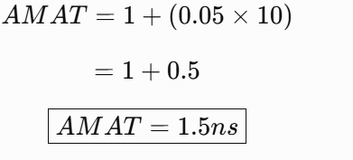

Analysis
If the miss rate increases to 10%:
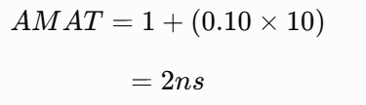

3.8 Memory Technology Comparison
The assignment requires comparison of SRAM, DRAM, NAND Flash, MRAM and RRAM.
Technology | Latency | Volatility | Density | Power | Suitable Application
SRAM | Very low | Volatile | Low | Higher per bit | L1/L2 cache
DRAM | Low/Medium | Volatile | High | Moderate | Main memory
NAND Flash | High | Non-volatile | Very high | Low standby | Storage
MRAM | Low | Non-volatile | High | Low | Embedded memory
RRAM | Potentially low | Non-volatile | High | Low | Future embedded/storage

3.9 SRAM Analysis
SRAM is fast and does not require refresh.
Therefore:
Best application: processor cache.
Disadvantage:
- Larger area
- Higher cost per bit
- Lower density

3.10 DRAM Analysis
DRAM provides high density at lower cost per bit than SRAM.
It requires periodic refreshing.
Best application:
Main Memory
3.11 NAND Flash Analysis
NAND Flash is non-volatile and provides high storage density.
Best application:
Program Storage
Data Logging
Industrial Event Records
It is unsuitable as the primary CPU cache because its latency is much higher than SRAM.

3.12 MRAM Analysis
MRAM is non-volatile and can provide relatively fast access.
Potential benefits include:
- Non-volatility
- Good endurance
- Low standby power
- Fast access
It can be considered for embedded memory and persistent data.
3.13 RRAM Analysis
RRAM uses resistance states to store information.
Potential advantages:
- High density
- Non-volatility
- Low power potential
- Scalability
It is attractive for future embedded and storage applications.

3.14 Memory Hierarchy Recommendation

Level | Recommended Technology | Reason
L1 | SRAM | Lowest latency
L2 | SRAM | High-speed access
L3 | SRAM | Large cache with low latency
Main Memory | DRAM | High capacity
Persistent Storage | NAND Flash | Non-volatile, high density
Future Embedded Memory | MRAM/RRAM | Non-volatile and energy-efficient potential

ASSESSMENT 4
RESULTS, COMPARISON & ENGINEERING RECOMMENDATION
4.1 Overall Architecture Comparison

Feature | Conventional Design | Proposed Design
Pipeline | Limited | 5-stage
Hazard Handling | Stalling | Forwarding + prediction
L1 Cache | Basic | Split I/D cache
L2 Cache | Basic | 512 KB
L3 Cache | Optional | 8 MB
Main Memory | DRAM | Low-power DRAM
Storage | Flash | NAND Flash
Virtual Memory | Basic | Paging + TLB
Execution | In-order | Controlled advanced techniques
Power Optimization | Limited | Clock/power management
Real-time Suitability | Medium | High

4.2 Performance Analysis
Assume:

Design A
CPI=1.5

Design B
CPI=1.2

IC=1,000,000
and:
f=1GHzf=1GHz

Design A
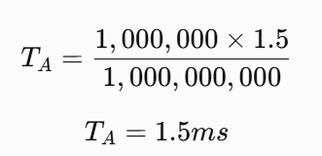
Design B
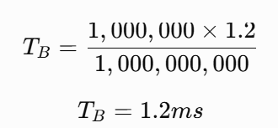
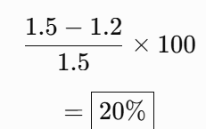

4.3 Bottleneck Analysis
The major possible bottlenecks are:
- Cache misses
- Branch misprediction
- Memory latency
- Pipeline hazards
- DRAM access
- Excessive power consumption
- I/O transfer delays

Proposed solutions:

Bottleneck | Solution
Cache misses | Larger L2/L3 + optimized locality
Data hazards | Forwarding
Load-use hazards | Controlled stalls
Branch hazards | Branch prediction
DRAM latency | Cache hierarchy
Power | Clock/power management

4.4 Final Engineering Recommendation
The recommended architecture is:

Recommendation
The processor should prioritize:
- Moderate clock frequency
- Low CPI
- Efficient pipeline
- Forwarding
- Branch prediction
- Large enough L2/L3 caches
- DRAM for main memory
- NAND Flash for persistent storage
- Low-power I/O
- Limited advanced execution features
A highly aggressive out-of-order and SMT design is not necessary for the primary application because it can increase power and complexity.

ASSESSMENT 5
REFLECTION, DESIGN DECISIONS, SDG RELEVANCE & LEARNING OUTCOMES

5.1 Design Decisions
The 5-stage pipeline was selected because it provides a reasonable balance between throughput and hardware complexity.
Forwarding was selected to reduce data hazards without introducing unnecessary stalls.
Branch prediction was selected to reduce control-hazard penalties.
A hierarchical cache was selected because the CPU is significantly faster than main memory. Keeping frequently used sensor data close to the processor reduces memory latency and energy consumption.
SRAM is used for caches because of its low latency, while DRAM is selected for main memory because it provides higher capacity at lower cost.
NAND Flash is selected for permanent storage because it is non-volatile and has high density.

5.2 SDG 7 – Affordable and Clean Energy
The design supports SDG 7 – Affordable and Clean Energy through energy-efficient processor operation.
Energy consumption can be reduced using:
- Lower unnecessary CPU activity
- Efficient cache usage
- Reduced memory accesses
- Pipeline optimization
- Clock gating

Reducing processor power consumption also reduces the energy required by industrial monitoring systems.

5.3 SDG 9 – Industry, Innovation and Infrastructure
The proposed processor directly supports SDG 9 – Industry, Innovation and Infrastructure.
Smart manufacturing requires:
- Real-time monitoring
- Automated decision-making
- Reliable infrastructure
- Efficient data processing
- Intelligent sensors
The proposed processor provides an architecture suitable for intelligent industrial systems.

5.4 SDG 12 – Responsible Consumption and Production
The architecture supports SDG 12 – Responsible Consumption and Production through efficient resource utilization.
Energy and hardware resources are used efficiently by:
- Reducing unnecessary computation
- Minimizing memory traffic
- Using suitable memory technologies
- Selecting appropriate cache sizes
- Reducing unnecessary hardware complexity
This helps reduce energy consumption and resource wastage.

5.5 Reflection
During the design process, the major challenge was balancing performance with energy consumption.
Increasing clock frequency can improve performance but generally increases power consumption. Similarly, advanced techniques such as out-of-order execution and SMT can improve utilization but require additional hardware and control logic.
The analysis demonstrates that the fastest architecture is not always the most suitable architecture for an industrial monitoring system.
The proposed design therefore emphasizes:
Possible future improvements include:
- AI/ML accelerator integration
- More advanced branch prediction
- MRAM/RRAM integration
- Adaptive voltage and frequency scaling
- Hardware accelerators for sensor processing
- More advanced power management

